
YOUR WINTER SERVICE PROPOSAL

Winter service proposal
  - 10 Meadowglen Drive
Whitby, Ontario
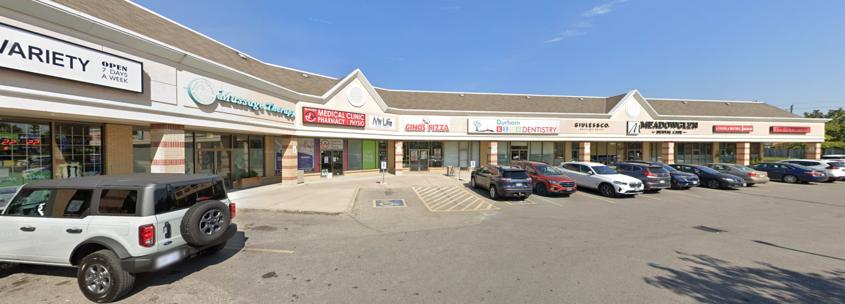
Prepared for Karma Investments
Attention B Brar
We propose a winter service plan built around your property, with unlimited snow plowing and 35 included salt applications for the highlighted parking, drive lanes and private sidewalks. Standard rock salt and a clear record of each visit are part of the plan.
Monthly cost before HST | Complete season before HST
$2,300.00 | $11,500.00

November 15, 2026 to April 15, 2027
Five monthly payments. Ontario HST at 13% is additional.
YOUR SERVICE AREAS

A clear plan for your property
The service areas shown below define the surfaces included in this proposal. They carry through to the separate agreement and its site instructions.
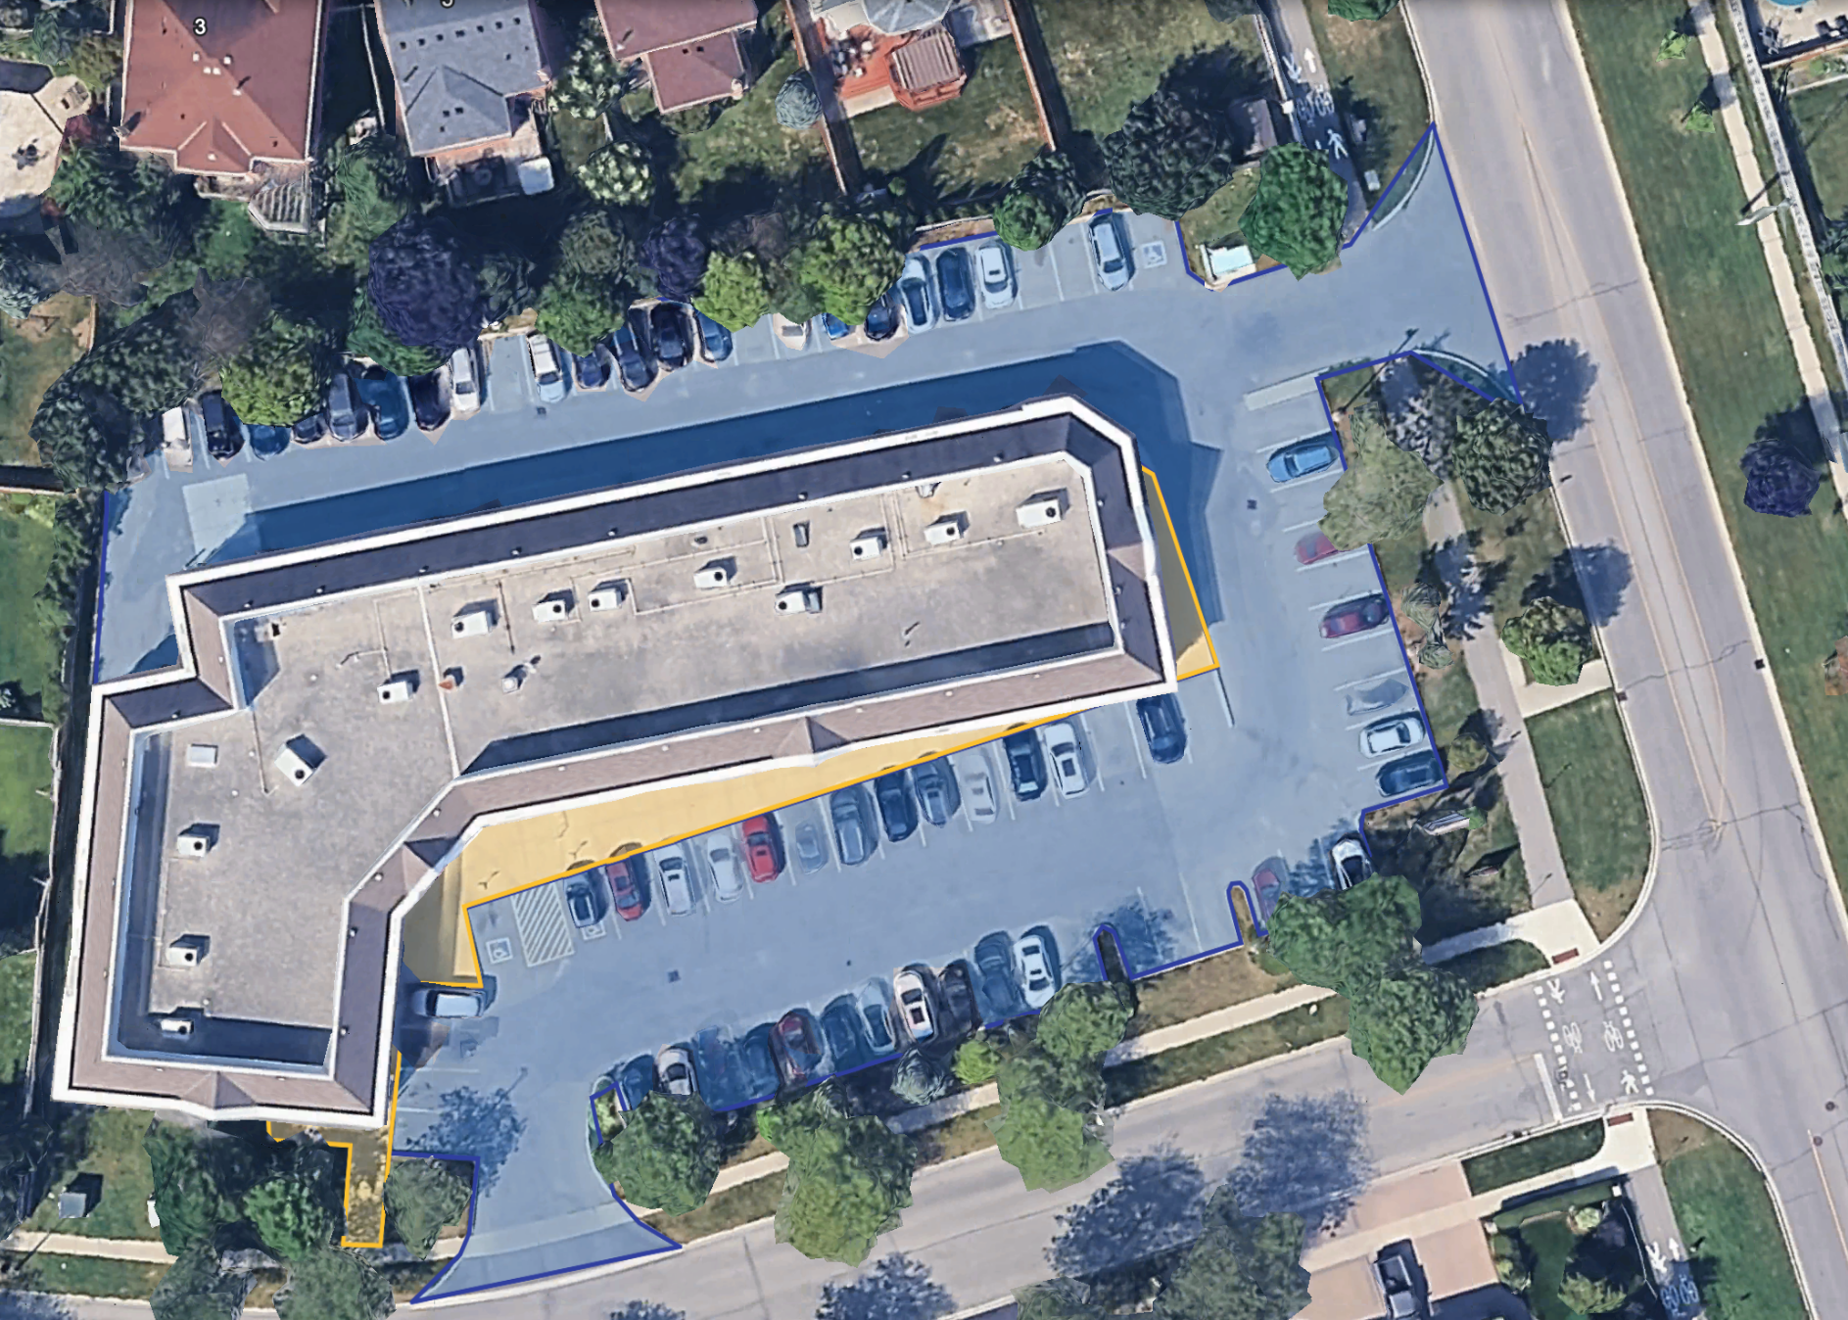
Map shading | Included surfaces
Blue and purple | Highlighted vehicle parking areas, drive lanes and entrance connections
Yellow | Highlighted private sidewalks and storefront approaches

Municipal sidewalks, public roads and areas outside the highlighted service coverage are excluded. Buildings, lawns and planted areas are not service surfaces.
YOUR SERVICE PLAN

Service around your business
Your seasonal plan includes unlimited snow plowing and 35 salt applications in the designated service areas. We plan each visit around the property, the weather and the access available when our crew arrives.

Snow plowing
The plowing trigger is 5 cm of accumulation in the serviced areas. During prolonged snowfall, interim passes are made where reasonably necessary to keep included priority entrances, exits and pedestrian routes usable, subject to safe operations. Detailed cleanup follows when accumulation eases and traffic permits.

Private sidewalks
The private sidewalks and storefront approaches highlighted in yellow are included for snow clearing and salting. Public sidewalks are excluded from this proposal. Parked vehicles and other obstructions can affect access to parts of the service area.

Salting
Your seasonal plan includes 35 salt applications with standard rock salt, labour and equipment, together with condition monitoring. Treatment is assessed below the plowing trigger, after clearing, during freezing rain and through thaw-freeze conditions. Repeat salt treatment attendances count toward the 35 applications. If more are needed, application 36 and each additional application are $195 plus HST. Salt takes time to work, and effectiveness varies with temperature and continuing precipitation.

Timing at 10 Meadowglen Drive
For overnight snow events, plowing will be completed overnight. During daytime snow events, laneways, entrances and sidewalks will be opened up, and cleanup will be completed overnight when the property is empty.
Service timing remains subject to safe operations, actual weather and access conditions, and the complete standards and qualifications in the agreement. Please keep included areas clear of vehicles and other obstructions where possible.

Winter service contact
Call 289-987-4044 for winter service concerns and urgent service requests. The line is available 24/7 during the service term. This is a winter service contact, not an emergency response service.
THE DPR EXPERIENCE

Quality matters in winter
We take the time to understand how your property is used, where access matters most and what the crew needs to know before a storm. The service map and property instructions make those expectations clear.
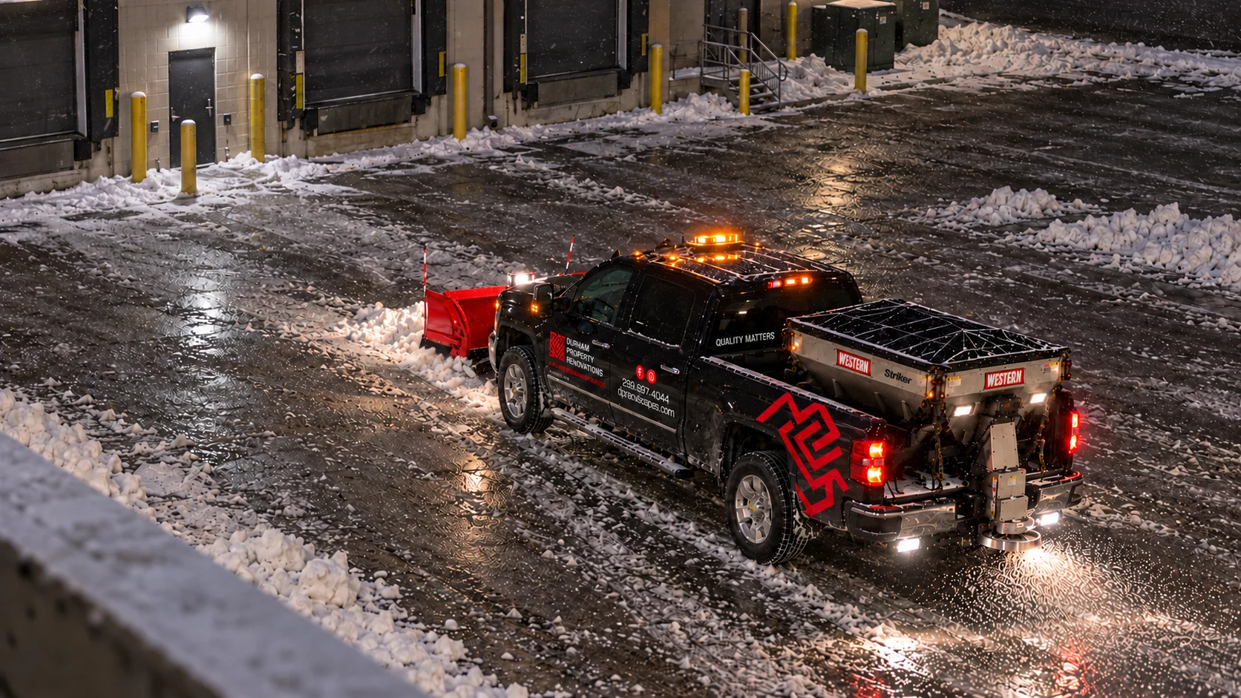
Snow-service illustrations. These images do not depict work completed at this property.

Service tailored to the property
Your plan covers the highlighted surfaces at 10 Meadowglen Drive, with daytime access passes and overnight cleanup as described in the property instructions. The crew can adjust the sequence of work to actual site and storm conditions while following the agreed service standards.

Care on site
DPR uses suitable labour, equipment and materials for the agreed services. Before the season, the service areas, known hazards and snow storage locations are reviewed with the property representative. Please advise us of access restrictions, concealed obstacles and changes to the site.

Communication and records
GPS attendance records and electronic service reports help you see when we attended and what was recorded. If weather, traffic or an obstruction causes a material delay, we communicate the delay and expected return. Monthly service logs are available on request.
SERVICE REPORTING

Know when we attend
Our service platform records visits and keeps your designated contact informed. Notifications and reports support the service record; the winter telephone remains the route for urgent concerns.

1 Weather planning
We monitor relevant forecasts, warnings and reported conditions to plan the services in your agreement. Conditions actually observed at the property guide the work performed.

2 Arrival notification
GPS geofencing generates an automated arrival notification for your designated recipient when an attendance event is recorded. We use reasonable efforts to deliver notifications in real time.

3 Completion report
After a visit, an electronic report identifies the services actually performed and available weather and site details. If a system interruption delays reporting, records are made available after the interruption.

4 Departure record
The platform generates a departure notification from the GPS geofence event. A geofence event alone does not prove that every task or area was completed or that salting occurred.
Visit record | Information recorded where applicable
Attendance | Date and attendance times
Services and areas | Work performed, treated surfaces and actual salting applications
Conditions | Available observations about weather, snow and site conditions
Follow-up and access | Areas not serviced and reasons, notes and next steps

Reporting workflow illustration only. This page is not a completed service report for 10 Meadowglen Drive.
Winter service concerns and requests: 289-987-4044
YOUR SEASONAL PRICE

A price you can budget for
Your seasonal plan includes unlimited snow plowing, 35 salt applications and clear service updates, with five scheduled payments. If additional salt applications are needed, they are $195 each plus HST. Authorized extras and any applicable fuel adjustment are invoiced separately under the agreement.
Price | Before HST | HST 13% | Including HST
Monthly installment | $2,300.00 | $299.00 | $2,599.00
Seasonal plan | $11,500.00 | $1,495.00 | $12,995.00

Service term: November 15, 2026 to April 15, 2027.
The seasonal charge covers availability and the included services during the term. Additional salting after the 35 included applications, authorized extras and any applicable fuel adjustment are billed separately under the agreement.

Your payment schedule
Each invoice is due 15 calendar days after issue. The final installment covers service through April 15, 2027.
Invoice date | Due date | Before HST | HST | Total
Nov 15, 2026 | Nov 30, 2026 | $2,300.00 | $299.00 | $2,599.00
Dec 15, 2026 | Dec 30, 2026 | $2,300.00 | $299.00 | $2,599.00
Jan 15, 2027 | Jan 30, 2027 | $2,300.00 | $299.00 | $2,599.00
Feb 15, 2027 | Mar 2, 2027 | $2,300.00 | $299.00 | $2,599.00
Mar 15, 2027 | Mar 30, 2027 | $2,300.00 | $299.00 | $2,599.00
Seasonal total |  | $11,500.00 | $1,495.00 | $12,995.00

Payment methods
Select your payment method in the agreement: post-dated cheques, wire transfer or e-transfer. Payment instructions and the invoice reference will be provided with your invoice. Selecting a method does not change the due date.
All prices are in Canadian dollars. Ontario HST at 13% is additional to the quoted base price.
ADDITIONAL SERVICES AND YOUR AGREEMENT

Complete service details
Salting beyond the 35 included applications follows the authorization in your agreement. Other additional services require prior written approval of scope and price, or an agreed calculation method. HST is additional.
Additional service | Rate before HST | Conditions
Additional salt application | $195 per application | After the 35 included seasonal applications
Snow hauling  Approximately 20 cubic yards | $1,500 per load | Subject to availability, safe loading and legal weight limits
Snow hauling  Approximately 14 cubic yards | $1,200 per load | Subject to availability, safe loading and legal weight limits
Snow pile relocation | $475 per hour | Three-hour minimum; billed from yard departure through return
Salt bin refill | $145 per full refill | Quarter, half and three-quarter fills billed proportionally

Bin refills are separate from applied salting, do not count toward the 35 included salt applications, and do not create an inspection or treatment service.

Fuel adjustment
A monthly fuel adjustment may apply above $2.00/L for gasoline or $2.75/L for diesel. Schedule C2 determines the benchmarks, eligible earned fees and calculation, with one combined 3% cap, no compounding and at least seven days' written notice before the first adjustment invoice.

Review your complete agreement
The separate Seasonal Snow and Ice Management Agreement contains the full service standards, selections, terms and Schedules A to D, together with the property service plan. Review it before signing.
Open your agreement, review the details, then sign and send it back to Jordan. We will take it from there.

Contact Jordan
DPR Landscapes | 289-987-4044
info@dprlandscapes.com
Durham Property Renovations Incorporated o/a DPR Landscapes
Mailing: 190 Hillside Avenue, Oshawa, Ontario L1J 1S9

